Low-Level Record of Concern Regarding a Staff Member

Please use this form to share any concern – no matter how small, and even if no more than a ‘nagging doubt’ – that an adult may have acted in a manner which:
- is not consistent with Orchard Partnership Academies Code of Conduct, and/or;
- relates to their conduct outside of work which, even if not linked to a particular act or omission, has caused a sense of unease about that adult’s suitability to work with children.
Where possible please speak with the Head Teacher or Head of School as soon as possible. It is also helpful to document your concerns, which can be done using this form and then passed to the Head/HoS. If the concern is about the Head/HoS, please pass it onto the Chair of Governors or email the clerk to the governing body of the prospective school.
Remember, a low-level concern is different to an allegation (which uses a different form). See the table below for a definition:
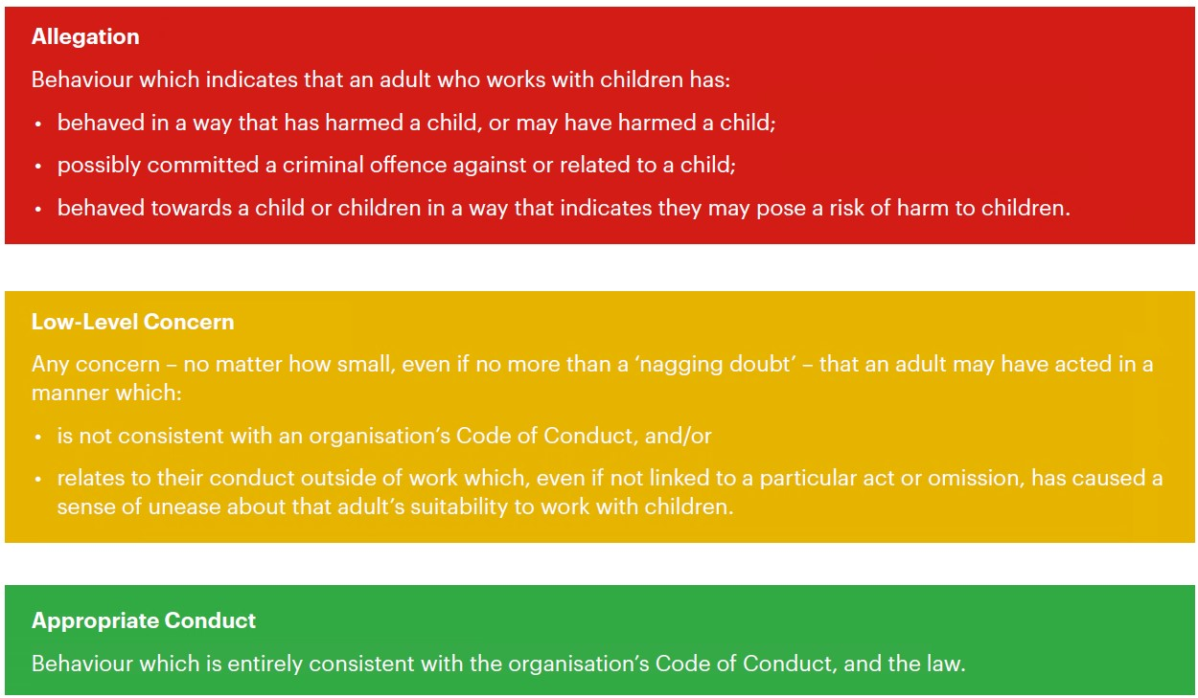
------------------------------------------------------------------------------------------------------------------------
Name of adult writing this concern:
Name of adult whom this concern is about:
Date written:
Signature:
Please write your concerns below (continue overleaf)
You should provide a concise record – including brief context in which the low-level concern arose, and details which are chronological, and as precise and accurate as possible – of any such concern and relevant incident(s) (and please use a separate sheet if necessary). Consider any contextual information that may be appropriate to know.

