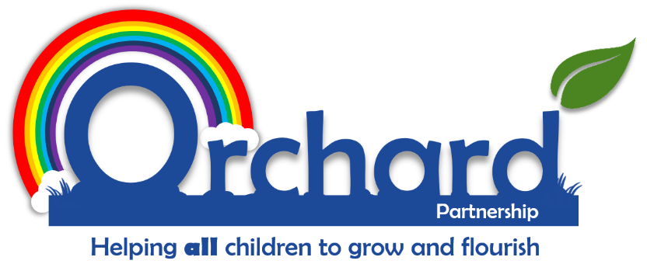

Orchard Partnership Academies
Charging and Remission Policy

Reviewed: Autumn 2021

Mr Alex Davies

Policy Writing Instructions:

- Use front cover as previous page.
- Change name and date it was reviewed (written). Do not put a ‘when next to be reviewed’ date in the policy.
- If writing a policy for an individual school – please use specific front cover.
- Font to be Calibri – Size 12 (in the main). Headings or key information can be enlarged.
- Please select page numbers to be bottom right hand corner – as per this template.
- Please check through to ensure the policy looks and flows correctly.

Please ensure you delete this box before finalising.

